**Name:** Safyan Anwar

**Roll no:** 018

**Section:** 3A-BSSE

**Assignment no:** 2

**Submitted to:** Sir. Rashik

**LAB TASK:**

**Code: “**find_maximum_value_in_time_complexity**”:**

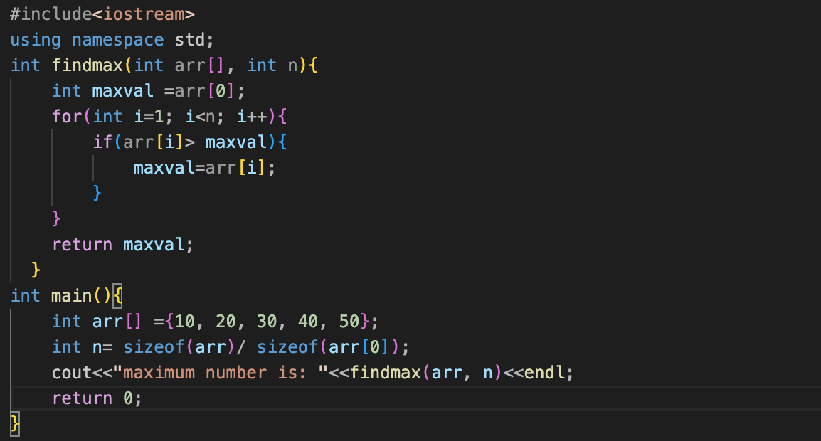

**Output:**

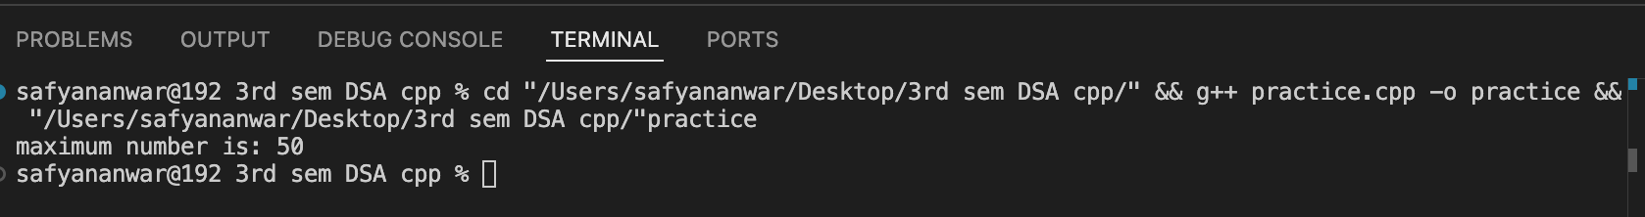

**Explain code:**

**Why it is O(n):-**

‘Linear iteration’ the loop goes through each of the n elements exactly once. ‘Constant Time Operations’ inside the loop the operations (comparison and assignment) are constant time operations i.e; O(1). ‘No loop’ there are no nested loop so the complexity does not increase beyond O(n).